Assignment 10

cryptology – b keerthana

AMRUTHESH

241059041

M.E – Cyber Security

MSIS, MANIPAL

**1. Prime Numbers from 1 to 100 Using Sieve of Eratosthenes**

The Sieve of Eratosthenes is an efficient way to find all prime numbers up to a given limit. Here’s how to implement it in Python:

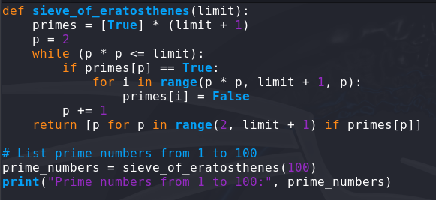

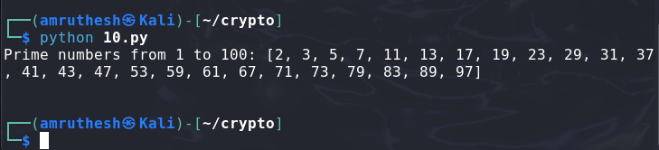

### 2. RSA Algorithm Using Python's Built-in Functions

To implement RSA, we’ll use Python’s rsa library (installable via pip install rsa). This library provides built-in functions for RSA key generation, encryption, and decryption.

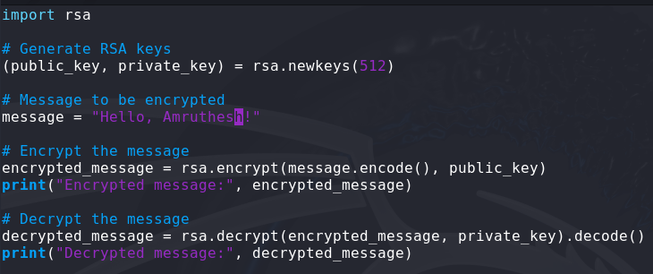

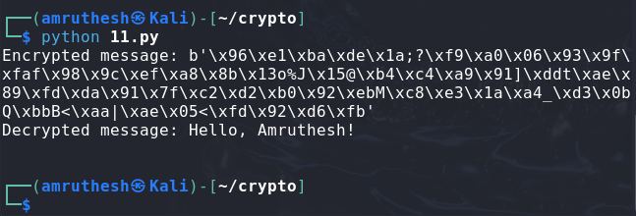

### 3. RSA Algorithm Without Using Built-in Functions

For a custom implementation, RSA encryption uses modular exponentiation, and we need to manually generate primes, compute the modulus nnn, and the totient ϕ(n)\phi(n)ϕ(n). Here’s a basic RSA implementation without using external libraries:

